CSC 120 Lab 03

* (+15) **Install VirtualBox on your system.**

In this exerise you will be installing Virtual Box on your system. (Windows or Mac). After installing VirtualBox you will be using it for installing a linux operating system by creating a Virtual Machine in Virtual Box. (Read online about what a virtual machine is).

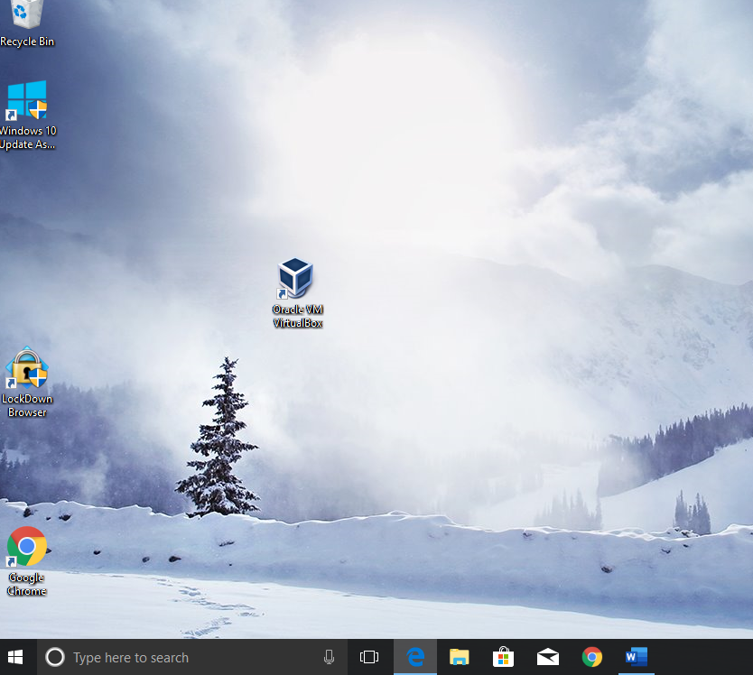

* (+15) **Explain what is a Virtual Machine**.

Why and how is are virtual machines used today? **Virtual Machines are used to run an operating system in an app window on your desktop. It can be used for testing software.**

How does VirtualBox help you create Virtual Machine? **VirtualBox uses a wizard to help create Virtual Machines**

What is the Host Operating System. How is it different from a Guest Operating System? **The host operating system is the OS that works with the actual computer. Guest OS works with the VM.**

* (+20) **Install Ubuntu 20.04 as a virtual machine using VirtualBox.**

**Step 0:** Open VirtualBox on your machine.

**Step 1:** Download the ISO for Ubuntu 20.04 to install it using Virtual Box.**Ubuntu 20.04 ISO Download Link** [**https://ubuntu.com/download/desktop**](https://ubuntu.com/download/desktop)

**Step 2:** Read more about what an ISO is below. **Note:** You just need to download an ISO for this exercise and not burn or mount one,The links provided give a lot more details about ISO which may not be relevant for this assignment,*]*

**Reading :** [**https://www.lifewire.com/iso-file-2625923**](https://www.lifewire.com/iso-file-2625923)

**Step 3:** Follow the steps provided in the tutorial below to install Ubuntu 20.04 using VirtuallBox.

**Ubuntu installation Video link:** [**https://youtu.be/3qcK_Bwa0sU**](https://youtu.be/3qcK_Bwa0sU)

**Ubuntu Installation Screenshotslink:** [**https://itsfoss.com/install-linux-in-virtualbox/**](https://itsfoss.com/install-linux-in-virtualbox/)

**Note:** Although the above tutorial is for installating Ubuntu 17.04, the steps are still the same.

* (+10) **Open the terminal and type whoami. Paste the screenshot of the command and the output below.**
* **Conceptual Question**
* (+5) Explain the concept of a process. What is the difference between a process that is ready vs waiting? **A process is a series of actions or steps taken to achieve a particular end. When a process is ready it can continue. When a process is waiting, it’s waiting for some events to happen to continue.**
* (+5) What is the distinction between application software and system software. Give an example of each. **System software manages the system software like an operating system like Windows or Linux. Application software that helps perform a function, like Excel or Word.**
* (+5) What is the difference between main memory and virtual memory? **Main memory is the physical memory of the computer. Virtual memory is hard drive space acting as temporary storage.**
* (+5) What are pages in virtual memory? Explain the concept of page size. **It is a fixed length continuous block of VM described by a single entity in the page table. It is the smallest unit of data for memory management in a WM OS.**
* (+5) Summarize the booting process. **The computer executes the boot loader program stored in the memory. The boot loader then transfers the OS from the mass storage to the main memory, then gives control to the OS.**
* What is the difference between an IO-bound process vs a compute-bound process? **IO bound is limited by the I/O subsystem and the Compute bound is limited by the speed of the CPU.**
* (+5) If both IO bound and compute bound process are waiting for a time slice which (+5) process should be given priority? Why? **The Compute bound process would be given priority because it can complete the task faster than an IO bound process.**
* (+5) What problem arises when the lengths of time slices in a multiprogramming system are made smaller and smaller? What happens when they are made longer and longer? **If time slices are smaller then the remaining time is wasting. When the time slice is made longer, then there is no time left to run the applications.**
* (+5) Explain the relationship between **semaphore**, **critical region** and **mutual exclusion. To enter the critical region, the software must find the semaphore clear before entering. Mutual exclusion happens because only one process can be executed at a time.**

**Instructions: Upload the file with the screenshot on Blackboard with youyr firstname_lastname.docx**